1. Enter House # or last name in the upper left search box and press enter.

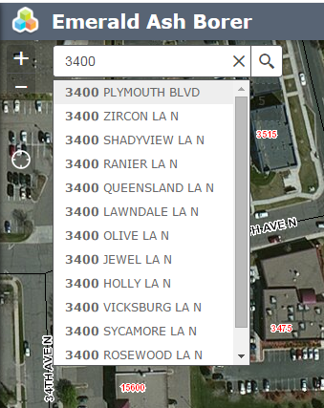

1. Choose your address or name from the dropdown list by clicking on the record.
2. To see information about a tree click on the blue/green/red circle on the map.

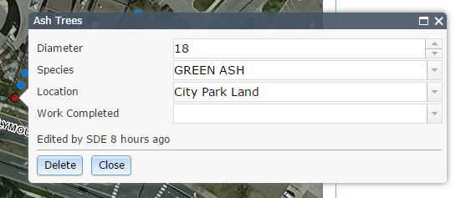

1. To add a tree from your yard select which type(Removed/Treated/Ash) from the right side “Edit” window and click on the map where it belongs. Add information to your tree using the dropdown boxes. Please be as complete as possible with your entries.

\*Note – It may take a few seconds after clicking on the map for the tree to show up.

